UNIT-1 FOUNDATIONAL AREAS OF ANALYTICS
Foundational Areas of Analytics Cognitive Science: Introduction to Analytics: Definition, Description & Evolution of Analytics, History of Analytics, and Applicability of Analytics with development of Technology and Computer, How Analytics entered mainstream
Concepts of Analytics: Various overlapping concepts and fields of Analytics such as Data Mining, Machine Learning, Artificial Intelligence and Simulation
Emerging Areas in Analytics: Understanding of emerging research areas of Analytics: Evolutionary computation, Simulation, Machine learning/data mining
Value Chain of Analytics: Descriptive Analytics Covering Exploratory Data Analysis & Basic of Statistics, Diagnostics Analytics: BI/Analysis, Trend, Pattern, Simultaneous Relationship.
Predictive Analytics: Cause-effect relationship and Futuristic prediction in terms of probabilities, Continuous & Categorical Predictions.
Introduction to the study of cognitive sciences, Brief history of cognitive science development and Methodological concerns in philosophy.
Foundational areas of Cognitive Psychology: Key Concepts - Nativism, Empiricism, Dualism, Structuralism, Functionalism.
Evolutionary theory
Lamarckism In the olden days people believed that all the organisms on the earth had not undergone any change. Jean Baptist Lamarck was the first person to propose the theory of evolution. He thought that at some point of time in the history the size of giraffe was equal to that of deer.
Due to shortage of food material on the ground and to reach the lower branches of trees giraffes started stretching their necks. Because of continuous stretching of neck, after several generations giraffes developed long necks. Such characters that are developed during the lifetime of an organism are called ‘acquired characters’. Lamarck proposed that these acquired characters are passed on to its offsprings i.e. to next generation and proposed the theory of ‘Inheritance of acquired characters’.
For example elongation of neck and forelimbs in giraffe. But August Weismann, tested this theory by an experiment on rats. He removed tails of parental rats. He observed that their offspring’s are normal with tails. He has done it again and again for twenty two generations but still offsprings are normal with tails. He proved that the bodily changes are not inherited. So they won’t be passed to it’s offsprings

Darwinism Charles Darwin proposed ‘Natural selection’ the famous ‘theory of evolution’.
Charles Darwin proposed ‘Natural selection’ the famous ‘theory of evolution’. Charles Darwin (1809-1882) was born in England. He voyaged for five years, just when he was 22 years old. In the world survey ship HMS Beagle. He visited a number of places including Galapagos Islands. He keenly observed the flora and fauna of these places. He gathered a lot of information and evidences.
Darwin observed a small group of related birds which are exhibiting diversity in structure in the Galapagos islands. These birds are Finch birds. Observe the fig-12. How do the beaks help them. He was influenced by the book ‘Principles of geology’ written by Sir Charles Lyell. He suggested that geological changes occured in a uniform rate, Darwin did not agree to this idea. He felt that large changes occured due to accumulation of small changes. Darwin was also influenced by the famous ‘Malthus theory’. This was written in ‘An essay on the principles of population’.
Malthus observed that population grows in geometrical progression (1, 2, 4, 8, ......) where as food sources increases in arithmetic progression (1, 2, 3, 4, 5, .......). fig-10: Giraffee SCERT Large ground finch (seeds) Cactus ground finc by Sir Charles Lyell. He suggested that geological changes occured TELANGANA characters are passed on to its offsprings i.e. to next generation and proposed the theory of ‘Inheritance of acquired characters’.
For example elongation of neck and forelimbs in giraffe. But August Weismann, tested this theory by an experiment on rats. He removed tails of parental rats. He observed that their offspring’s are normal with tails. He has done it again and again for twenty two generations but still offsprings are normal with tails. He proved that the bodily changes are not inherited. So they Charles Darwin proposed ‘Natural selection’ the famous ‘theory of Charles Darwin (1809-1882) was born in England. He voyaged for five years, just when he was 22 years old. In the world survey ship HMS Beagle.
He visited a number of places including Galapagos Islands. He keenly observed the flora and fauna of these places. He gathered a lot of information and evidences. Darwin observed a small group of related birds which are exhibiting diversity in structure in the Galapagos islands. These birds are Finch birds. Observe the fig-12. How do the beaks help them. He was influenced by the book ‘Principles of geology’ written by Sir Charles Lyell.
He suggested that geological changes Based on these ideas, Darwin proposed the theory of “Natural selection”, which means that the nature only selects or decides which organism should survive or perish in nature. This is the meaning of survival of the fittest.
The organisms with useful traits will survive. If traits are not usefull to organisms then they are going to be perished or eliminated from its environment Alfred Russel Wallace also independently concluded that natural selection contributed to origin of new species.
For example we have seen in the case of red beetles which were seen and eaten by crows. So, the population of red beetles gradually got eliminated or perished from its environment. But at the same time the beetles which are green in colour which are present on the green leaves were not noticed by crows. So the green beetles survived in the environment and their population have gradually increased. This is nothing but “natural selection” Variations which are useful to an individual are retained, while those which are not useful are lost. In a population when there is a struggle for the existence the ‘fittest’ will be survived.
Nature favours only useful variations. Each species tend to produce large number of offsprings. They compete with each other for food, space, mating and other needs. In this struggle for existence, only the fittest can survive. This is called ‘survival of the fittest’. Over a long period of time this leads to the formation of new species. You may observe in your surroundings some seedlings and some of the animal kids only survive. Darwin’s theory of evolution in a nutshell
1. Any group of population of an organism develops variations and all members of group are not identical. 2. Variations are passed from parent to offspring through heredity.
3. The natural selection over abundance of offspring leads to a constant struggle for their survival in any population
4. Individuals with variations that help them to survive and reproduce tend to live longer and have more offsprings than organisms with less useful features.
5. The offsprings of survivors inherit the useful variations, and the same process happens with every new generation until the variation becomes a common feature.
6. As the environment changes, the organism within the environment adapt and changes to the new living conditions.
7. Over a long period of time, each species of organism can accumulate so many changes that it becomes a new species, similar to but distinctly different from the original species. All species on the earth arise in this way.
8. Evolution is a slow and continuous process. There are some limitations and objections to the Darwin theory. Many new theories like synthetic theory, mutation theory are put forward
Speciation
How new species are evolved?
We have seen variations in a population of species, where the organism contain the traits that helped to adapt to the environment. These organisms are going to survive more efficiently. But in the same population the organism which contains the non beneficial traits may not be adapted in the environment. They are going to perish or eliminated slowly, like red and blue beetles in a population which we have discussed earlier in this chapter. These small changes within the species for example colour of beetles red and green is known as micro evolution. Now we are going to discuss how new species are formed. This is known as speciation, which is also known as Macroevolution. We have seen red and green beetles can mate each other and can have offsprings. But let us imagine that red and green beetles are separated by some cause (for example while eating beetles crows dropped some beetles accidently in the long-distance faraway places) for long years. There might be a lot of variations taken place in these years in the red and green beetle population. Now even though they may meet accidentally, they cannot mate and produce new offsprings. They can only mate in their population either red or green and can reproduce its off spring. Thus, new species have been formed. Evidences of evol

Variations in beetle population Observe the below diagram showing variation in beetle population and it its impact. This is only an assumption.
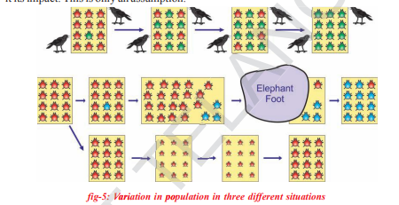
Let us consider a group of twelve beetles. They live in bushes on green leaves. Their population will grow by sexual reproduction. So they were able to generate variations in population. Let us assume crows eat these red beetles. If the crows eat more Red beetles their population slowly reduced. Let us discuss the above in three different situations in detail. Situation-1: In this situation a colour variation arises during reproduction. So that there appears one beetle that is green in colour instead of red

More over this green coloured beetle passes it’s colour to it’s off spring (Progeny). So that all its progeny are green. Crows cannot see the green coloured beetles on green leaves of the bushes and therefore crows cannot eat them. But crows can see the red beetles and eat them. As a result there are more and more green beetles than red ones which decrease in their number. The variation of colour in beetle ‘green’ gave a survival advantage to ‘green beetles’ than red beetles. In other words it was naturally selected. We can see that the ‘natural selection’ was exerted by the crows. The more crows there are, the more red beetles would be eaten and the more number of green beetles in the population would be. Thus the natural selection is directing evolution in the beetle population. It results in adaptation in the beetle population to fit in their environment better. Let us think of another situation
Situation-2:
In this situation a colour variation occurs again in its progeny during reproduction, but now it results in ‘Blue’ colour beetles instead of ‘red’ colour beetle. This blue colour beetle can pass its colour to its progeny. So that all its progeny are blue. fig-7: Blue and red beetle Crows can see blue coloured beetles on the green leaves of the bushes and the red ones as well. And therefore crows can eat both red and blue coloured beetles. In this case there is no survival advantage for blue coloured beetles as we have seen in case of green coloured beetles. What happens initially in the population, there are a few blue beetles, but most are red. Imagine at this point an elephant comes by and stamps on the bushes where the beetles live. This kills most of the beetles. By chance the few beetles survived are mostly blue. Again the beetle population slowly increases. But in the beetle population most of them are in blue colour. Thus sometimes accidents may also result in changes in certain characters of the a population. Characters as we know are governed by genes. Thus, there is change in the frequency of genes in small populations. This is known as “Genetic drift’, which provides diversity in the population.
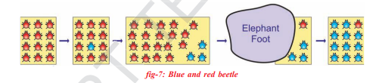
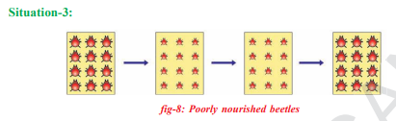
In this case beetle’s population is increasing, but suddenly bushes were affected by a plant disease in which leaf material were destroyed or in which leaves are affected by this beetles got less food material. So beetles are poorly nourished. So the weight of beetles decrease but no changes take place in their genetic material (DNA). After a few years the plant disease are eliminated. Bushes are healthy with plenty of leaves. What do you think will be condition of the beetles
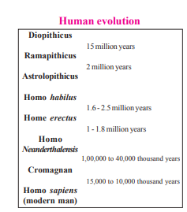
We inherited our traits from our parents. Let us see how sex is determined in human beings. Each human cell contains 23 pairs (46) of chromosomes. Out of 23 pairs 22 pairs of chromosomes are autosomes. Chromosomes whose number and morphology do not differ between males and females of a species are called autosomes. The remaining pair is called allosomes or sex chromosomes. These are two types, one is ‘X’ and the other is ‘Y’. These two chromosomes determine the sex of an individual. Females have two ‘X’ chromosomes in their cells (XX). Males have one ‘X’ and one ‘Y’ chromosomes in their cells (XY). All the gametes (ova) produced by a woman have only X chromosomes. The gametes (sperm) produced by a man are of two types one with X chromosome and other Y chromosome. If the sperm carries Y chromosome and fertilizes the ovum (X chromosome). Then the baby will have XY condition. So the baby will be a boy. mother’s sex chromosomes father’s sex chromosomes male child female child Father Mother Baby girl Baby boy Baby girl Baby boy 22 +X 22 +Y 22+X 22+X (44+XX) (44+XY) (44+XX) (44+XY) Parents Gametes Offsping 44+XY 44+XX Gyno Sperm Andro Sperm Eggs What will happen if the sperm containing X chromosomes fertilizes the ovum? Who decides the sex of the baby – mother or father? Is the sex also a character or trait? Does it follow Mendels’ law of dominance? Were all your traits similar to that of your parents?
Sex determination in human beings
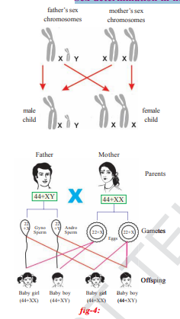
Ant Colony Optimization
The algorithmic world is beautiful with multifarious strategies and tools being developed round the clock to render to the need for high-performance computing. In fact, when algorithms are inspired by natural laws, interesting results are observed. Evolutionary algorithms belong to such a class of algorithms. These algorithms are designed so as to mimic certain behaviours as well as evolutionary traits of the human genome. Moreover, such algorithmic design is not only constrained to humans but can be inspired by the natural behaviour of certain animals as well. The basic aim of fabricating such methodologies is to provide realistic, relevant and yet some low-cost solutions to problems that are hitherto unsolvable by conventional means.
Different optimization techniques have thus evolved based on such evolutionary algorithms and thereby opened up the domain of metaheuristics. Metaheuristic has been derived from two Greek words, namely, Meta meaning one level above and heuriskein meaning to find. Algorithms such as the Particle Swarm Optimization (PSO) and Ant Colony Optimization (ACO) are examples of swarm intelligence and metaheuristics. The goal of swarm intelligence is to design intelligent multi-agent systems by taking inspiration from the collective behaviour of social insects such as ants, termites, bees, wasps, and other animal societies such as flocks of birds or schools of fish.
Background:
Ant Colony Optimization technique is purely inspired from the foraging behaviour of ant colonies, first introduced by Marco Dorigo in the 1990s. Ants are eusocial insects that prefer community survival and sustaining rather than as individual species. They communicate with each other using sound, touch and pheromone. Pheromones are organic chemical compounds secreted by the ants that trigger a social response in members of same species. These are chemicals capable of acting like hormones outside the body of the secreting individual, to impact the behaviour of the receiving individuals. Since most ants live on the ground, they use the soil surface to leave pheromone trails that may be followed (smelled) by other ants.
Ants live in community nests and the underlying principle of ACO is to observe the movement of the ants from their nests in order to search for food in the shortest possible path. Initially, ants start to move randomly in search of food around their nests. This randomized search opens up multiple routes from the nest to the food source. Now, based on the quality and quantity of the food, ants carry a portion of the food back with necessary pheromone concentration on its return path. Depending on these pheromone trials, the probability of selection of a specific path by the following ants would be a guiding factor to the food source. Evidently, this probability is based on the concentration as well as the rate of evaporation of pheromone. It can also be observed that since the evaporation rate of pheromone is also a deciding factor, the length of each path can easily be accounted for.
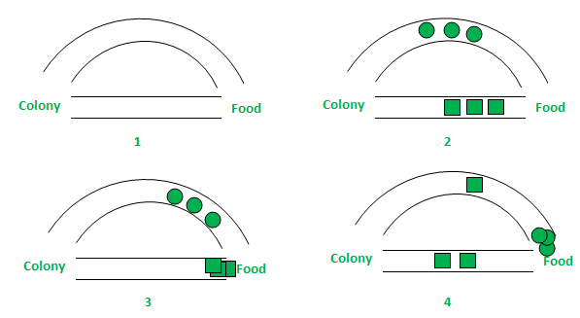
In the above figure, for simplicity, only two possible paths have been considered between the food source and the ant nest. The stages can be analyzed as follows:
- Stage 1: All ants are in their nest. There is no pheromone content in the environment. (For algorithmic design, residual pheromone amount can be considered without interfering with the probability)
- Stage 2: Ants begin their search with equal (0.5 each) probability along each path. Clearly, the curved path is the longer and hence the time taken by ants to reach food source is greater than the other.
- Stage 3: The ants through the shorter path reaches food source earlier. Now, evidently they face with a similar selection dilemma, but this time due to pheromone trail along the shorter path already available, probability of selection is higher.
- Stage 4: More ants return via the shorter path and subsequently the pheromone concentrations also increase. Moreover, due to evaporation, the pheromone concentration in the longer path reduces, decreasing the probability of selection of this path in further stages. Therefore, the whole colony gradually uses the shorter path in higher probabilities. So, path optimization is attained.
Algorithmic Design:
Pertaining to the above behaviour of the ants, an algorithmic design can now be developed. For simplicity, a single food source and single ant colony have been considered with just two paths of possible traversal. The whole scenario can be realized through weighted graphs where the ant colony and the food source act as vertices (or nodes); the paths serve as the edges and the pheromone values are the weights associated with the edges.
Let the graph be G = (V, E) where V, E are the edges and the vertices of the graph. The vertices according to our consideration are V_{s} (Source vertex – ant colony) and V_{d} (Destination vertex – Food source), The two edges are E₁ and E₂ with lengths L₁ and L₂ assigned to each. Now, the associated pheromone values (indicative of their strength) can be assumed to be R₁ and R₂ for vertices E₁ and E₂ respectively. Thus for each ant, the starting probability of selection of path (between E₁ and E₂) can be expressed as follows:
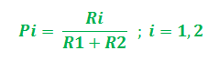
Evidently, if R₁>R₂, the probability of choosing E₁ is higher and vice-versa. Now, while returning through this shortest path say E_{i}, the pheromone value is updated for the corresponding path. The updation is done based on the length of the paths as well as the evaporation rate of pheromone. So, the update can be step-wise realized as follows:
- In accordance to path length –
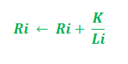
In the above updation, i = 1, 2 and ‘K’ serves as a parameter of the model. Moreover, the update is dependent on the length of the path. Shorter the path, higher the pheromone added.
- In accordance to evaporation rate of pheromone –
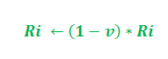
The parameter ‘v’ belongs to interval (0, 1] that regulates the pheromone evaporation. Further, i = 1, 2.
At each iteration, all ants are placed at source vertex V_{s} (ant colony). Subsequently, ants move from V_{s} to V_{d} (food source) following step 1. Next, all ants conduct their return trip and reinforce their chosen path based on step 2.
Pseudocode:
Procedure AntColonyOptimization:
Initialize necessary parameters and pheromone trials;
while not termination do:
Generate ant population;
Calculate fitness values associated with each ant;
Find best solution through selection methods;
Update pheromone trial;
end while
end procedure
The pheromone update and the fitness calculations in the above pseudocode can be found through the step-wise implementations mentioned above.
Thus, the introduction of the ACO optimization technique has been established. The application of the ACO can be extended to various problems such as the famous TSP (Travelling Salesman Problem).

What is Genetic Engineering
- In simple words, genetic engineering can be described as the manual addition of a new DNA into an organism.
- It aids the addition of such traits that are not originally found in the organisms.
- Recombinant DNA is required to create Genetically Modified Organisms (GMO.)
- An area of chromosome (gene) is spliced.
- Genetic disorders in humans can be corrected using genetic engineering.
- Selective breeding has been in the world since ancient times.
- Jack Williamson used the word ‘Genetic Engineering’ in his science fiction novel Dragon’s Island which was published in 1951.
- First recombinant DNA molecules were created by an American Biochemist, Paul Berg.
New DNA may be inserted in the host genome by first isolating and copying the genetic material of interest using molecular cloning methods to generate a DNA sequence, or by synthesizing the DNA and then inserting this construct into the host organism. Genes may be removed, or “knocked out”, using a nuclease. Gene targeting is a different technique that uses homologous recombination to change an endogenous gene and can be used to delete a gene, remove exons, add a gene, or introduce point mutations.
Aspirants reading, ‘GEAC’ can also refer to topics lined below:
GM Crops | High Yield Crops in India | Mission Innovation

Applications of Genetic Engineering
Medicine, research, industry and agriculture are a few sectors where genetic engineering applies. It can be used on various plants, animals and microorganisms. The first microorganism to be genetically modified is bacteria.
- In Medicine: Genetic engineering can be applied to:
  - Manufacturing of drugs
  - Creation of model animals that mimic human conditions and,
  - Gene therapy
  - Human growth hormones
  - Follicle-stimulating hormones
  - Human albumin
  - Monoclonal antibodies
  - Antihemophilic factors
  - Vaccines
- In Research: Genes and other genetic information from a wide range of organisms can be inserted into bacteria for storage and modification, creating genetically modified bacteria in the process.
- In Industry:
  - Transformation of cells in organisms with a gene coding to get a useful protein.
  - Medicines like insulin, human growth hormone, and vaccines, supplements such as tryptophan, aid in the production of food (chymosin in cheese making) and fuels are produced using such techniques.
- In Agriculture:
  - Genetically modified crops are produced using genetic engineering in agriculture.
  - Such crops are produced that provide protection from insect pests.
  - It is used or can be used in the creation of fungal and virus-resistant crops.
- Genetic engineering can be applied to other areas:
  - Conservation
  - Natural area management
  - Microbial art

Benefits of Genetic Engineering
- The production of genetically modified crops is a boon to agriculture.
- The crops that are drought-resistant, disease-resistant can be grown with it.
- As described earlier, genetic disorders can be treated.
- The diseases such as malaria, dengue can be eliminated by sterilising the mosquitoes using genetic engineering.
- Therapeutic cloning

Challenges of Genetic Engineering
- The production of genetically-engineered entities may result in an adverse manner and produce undesired results which are unforeseen.
- With the introduction of a genetically-engineered entity into one ecosystem for a desirable result, may lead to distortion of the existing biodiversity.
- Genetically-engineered crops can also produce adverse health effects.
- The concept of genetic-engineering is debated for its bioethics where community against it argue over the right of distorting or moulding the nature as per our needs.
1.3.3 | Data Science Data Science is the most important component of analytics, it consists of statistical and operations research techniques, machine learning and deep learning algorithms. Given a problem, the objective of the data science component of analytics is to identify the most appropriate statistical model/machine learning algorithm that can be used. For example, Target’s pregnancy prediction is a classification problem in which customers (or entities) are classified into different groups. In the case of pregnancy test, the classes are: 1. Pregnant 2. Not pregnant 10 Business Analytics There are several techniques available for solving classification problems such as logistic regression, classification trees, random forest, adaptive boosting, neural networks, and so on. The objective of the data science component is to identify the technique that is best based on a measure of accuracy. Usually, several models are developed for solving the problem using different techniques and a few models may be chosen for deployment of the solution. Business analytics can be grouped into three types: descriptive analytics, predictive analytics, and prescriptive analytics. In the following sections, we shall discuss the three types of analytics in detail.

In God we trust; all others must bring Data —Edwards Deming The epigraph captures the importance of analytics and data-driven decision making in one sentence. During the early period of the 20th century, many companies were taking business decisions based on ‘opinions’ rather than decisions based on proper data analysis (which probably acted as a trigger for Deming’s quote). Opinion-based decision making can be very risky and often leads to incorrect decisions. One of the primary objectives of business analytics is to improve the quality of decision making using data analysis, which is the focus of this book. Every organization across the world uses performance measures such as market share, profitability, sales growth, return on investment (ROI), customer satisfaction, and so on for quantifying, monitoring, benchmarking, and improving its performance. It is important for organizations to understand the association between key performance indicators (KPIs) and factors that have a significant impact on the KPIs for effective management. Knowledge of the relationship between KPIs and factors would provide the decision maker with appropriate actionable items. Analytics is a body of knowledge consisting of statistical, mathematical, and operations research techniques; artificial intelligence techniques such as machine learning and deep learning algorithms; data collection and storage; data management processes such as data extraction, transformation, and loading (ETL); and computing and big data technologies such as Hadoop, Spark, and Hive that create value by developing actionable items from data. Two primary macro-level objectives of analytics are problem solving and decision making. Analytics helps organizations to create value by solving problems effectively and assisting in decision making. Today, analytics is used as a competitive strategy by many organizations such as Amazon, Apple, General Electric, Google, Facebook and Procter and Gamble who use analytics to create products and solutions. Marshall (2016) and MacKenzie et al. (2013) reported that Amazon’s recommender systems resulted in a sales increase of 35%. Davenport and Harris (2007) and Hopkins et al. (2010) reported that there was a high correlation between use of analytics and business performance. They claimed that the majority of high performers (measured in terms of profit, shareholder return and revenue, etc.) strategically apply analytics in their daily operations, as compared to low performers.
A few of the problems that e-commerce companies such as Amazon and Flipkart try to address are as follows:
1. Forecasting demand for products directly sold by the company; excess inventory and shortage can impact both the top line and the bottom line.
2. Cancellation of orders placed by customers before their delivery. Ability to predict cancellations and intervention can save cost incurred on unnecessary logistics.
3. Fraudulent transactions resulting in financial loss to the company.
4. Predicting delivery time since it is an important service level agreement from the customer perspective.
5. Predicting what a customer is likely to buy in future to create recommender systems. Given the scale of operations of modern companies, it is almost impossible to manage them effectively without analytics. Although decisions are occasionally made using the HiPPO algorithm (“highest paid person’s opinion” algorithm), especially in a group decision-making scenario, there is a significant change in the form of “data-driven decision making” among several companies. Many companies use analytics as a competitive strategy and many more are likely to follow.
A typical data-driven decision-making process uses the following steps (Figure 1.1):
1. Identify the problem or opportunity for value creation.
2. Identify sources of data (primary as well secondary data sources).
3. Pre-process the data for issues such as missing and incorrect data. Generate derived variables and transform the data if necessary. Prepare the data for analytics model building.
4. Divide the data sets into subsets training and validation data sets.
5. Build analytical models and identify the best model(s) using model performance in validation data.
6. Implement Solution/Decision/Develop Product. Analytics is used to solve a wide range of problems starting with simple process improvement such as reducing procurement cycle time to complex decision-making problems such as farm advisory systems that involve accurate weather prediction, forecasting commodity price etc, so that farmers can be advised about crop selection, crop rotation, etc. Figure 1.2 shows the pyramid of analytics applications, at the bottom of the pyramid analytics is used for process improvement and at the top it is used for decision making and as a competitive strategy.
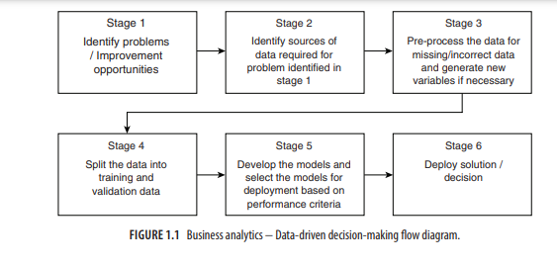
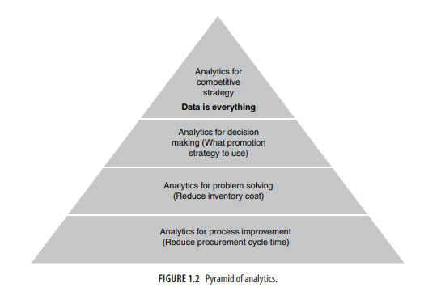
WHY ANALYTICS According to the theory of firm (Coase, 1937 and Fame, 1980) as proposed by several economists, firms exist to minimize the transaction cost. Transactions take place when goods or services are transferred to customers from the supplier. The cost of decision making is an important element of transaction cost. Michalos (1970) groups the costs of decision making into three categories:
1. Cost of reaching a decision with the help of a decision maker or procedure; this is also known as production cost, that is, cost of producing a decision.
2. Cost of actions based on decisions produced; also known as implementation cost.
3. Failure costs that account for failure of an organization’s efforts on production and implementation.
For example, consider a firm that would like to sell product such as a readymade shirt. The firm has to take several decisions such as fabric, colour, size, fit, price, promotion, and so on. Each of these attributes has several options. The real problem starts with decision-making ability of firms, especially the techniques and processes used in decision making; unfortunately, human beings are inherently not good at decision making. A great example for human’s inability to take decisions is the famous Monty Hall problem (Savant, 1990) in which the contestants of a game show are shown three doors (Figure 1.3). Behind one of the doors is an expensive item (such as a car or gold); while there are inexpensive items behind the remaining two doors (such as a goat). The contestant is asked to choose one of the doors. Assume that the contestant chooses door 1; the game host would then open one of the remaining two doors. Assume that the game host opens door 2, which has a goat behind it. Now the contestant is given a chance to change his initial choice (from door 1 to door 3). The problem is whether or not the contestant should change his/her initial choice. Note that the contestant is given an option to switch door irrespective of the item behind his/her original choice of door. The problem is based on a famous television show “Let’s make a deal” hosted by Monty Hall in 1960s and 1970s (Selvin, 1975). In this problem, the contestant — the decision maker — has two choices: he/she can either change his/her initial choice or stick with his/her initial choice. When Marilyn vos Savant, a columnist at the Parade Magazine, posted that the contestant should change the initial choice (Savant, 1990), 92% of the general public and 65% of the university graduates (many of them with PhDs) who responded to her column were against her answer.1 Although Marilyn vos Savant provided a simple decision tree
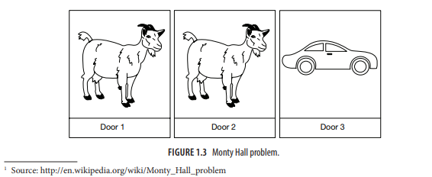
argument to prove that the probability of winning increases to 2/3 when the contestant changes his/ her initial choice, many scholars did not accept her argument that changing the initial option is the right decision. Table 1.1 shows why changing the initial option increases the probability of winning. The expensive item can be behind any one of the three doors as shown in Table 1.1 (rows 2−4). Assume that the contestant has chosen door 1 initially, columns 4 and 5 (last row) give the probability of winning the car if contestant stays with door 1 (column 4) and the door 1 is changed (column 5), respectively. The above argument can be extended to any number of doors without loss of generality. In the case of Monty Hall problem, the number of alternatives available to the player is just two. Even when the number of options is only 2, many find it difficult to comprehend that changing the initial choice will increase the probability of winning
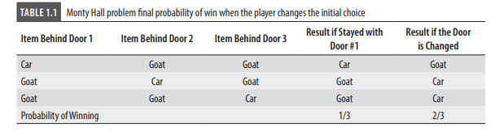
Business analytics is a set of statistical and operations research techniques, artificial intelligence, information technology and management strategies used for framing a business problem, collecting data, and analysing the data to create value to organizations.
Business Analytics can be broken into 3 components:
1. Business Context
2. Technology
3. Data Science
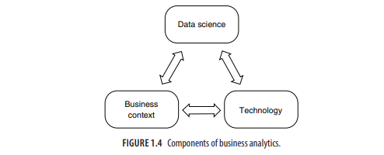
DESCRIPTIVE ANALYTICS “If the statistics are boring, then you’ve got the wrong numbers”. —Edward R. Tufte Descriptive analytics is the simplest form of analytics that mainly uses simple descriptive statistics, data visualization techniques, and business related queries to understand past data. One of the primary objectives of descriptive analytics is innovative ways of data summarization. Descriptive analytics is used for understanding the trends in past data which can be useful for generating insights. Figure 1.5 shows visualization of relationship break-ups reported in Facebook. It is clear from Figure 1.5 that spike in breakups occurred during spring break and in December before Christmas. There could be many reasons for increase in breakups during December (we hope it is
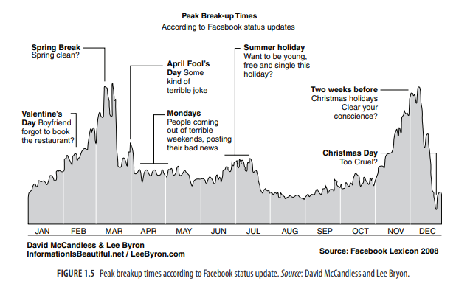
not a New Year resolution that they would like to change the partner). Many believe that since December is a holiday season, couples get a lot of time to talk to each other, probably that is where the problem starts. However, descriptive analytics is not about why a pattern exists, but about what the pattern means for a business. The fact that there is a significant increase in breakups during December we can deduce the following insights (or possibilities):
1. There will be more traffic to online dating sites during December/January.
2. There will be greater demand for relationship counsellors and lawyers.
3. There will be greater demand for housing and the housing prices are likely to increase in December/January.
4. There will be greater demand for household items.
5. People would like to forget the past, so they might change the brand of beer they drink. Descriptive analytics using visualization identifies trends in the data and connects the dots to gain insights about associated businesses. In addition to visualization, descriptive analytics uses descriptive statistics and queries to gain insights from the data.
The following are a few examples of insights obtained using descriptive analytics reported in literature:
1. Most shoppers turn towards the right side when they enter a retail store (Underhill, 2009, pages 77−79). Retailers keep products with higher profit on the right side of the store since most people turn right.
2. Married men who kiss their wife before going to work live longer, earn more and get into less number of accidents as compared to those who do not (Foer, 2006).
3. Correlated with Facebook relationship breakups, divorces spike in January. According to Caroline Kent (2015), January 3 is nicknamed ‘divorce day’.
4. Men are more reluctant to use coupons as compared to women (Hu and Jasper, 2004). While sending coupons, retailers should target female shoppers as they are more likely to use coupons. Trends obtained through descriptive analytics can be used to derive actionable items
PREDICTIVE ANALYTICS If you torture the data long enough, it will confess. —Ronald Coase In the analytics capability maturity model (ACMM), predictive analytics comes after descriptive analytics and is the most important analytics capability. It aims to predict the probability of occurrence of a future event such as forecasting demand for products/services, customer churn, employee attrition, loan defaults, fraudulent transactions, insurance claim, and stock market fluctuations. While descriptive analytics is used for finding what has happened in the past, predictive analytics is used for predicting what is likely to happen in the future. The ability to predict a future event such as an economic slowdown, a sudden surge or decline in a commodity’s price, which customer is likely to churn, what will be the total claim from auto insurance customer, how long a patient is likely to stay in the hospital, and so on will help organizations plan their future course of action. Anecdotal evidence suggests that predictive analytics is the most frequently used type of analytics across several industries. The reason for this is that almost every organization would like to forecast the demand for the products that they sell, prices of the materials used by them, and so on. Irrespective of the type of business, organizations would like to forecast the demand for their products or services and understand the causes of demand fluctuations. The use of predictive analytics can reveal relationships that were previously unknown and are not intuitive. 3 Source: https://gramener.com/
Business Analytics The most popular example of the application of predictive analytics is Target’s pregnancy prediction model discussed earlier in the chapter. In 2002, Target hired statistician Andrew Pole; one of his assignments was to predict whether a customer is pregnant (Duhigg, 2012). At the outset, the question posed by the marketing department to Pole may look bizarre, but it made great business sense. Any marketer would like to identify the price-insensitive customers among the shoppers, and who can beat soon-to-be parents? A list of interesting applications of predictive analytics is presented in Table 1.2
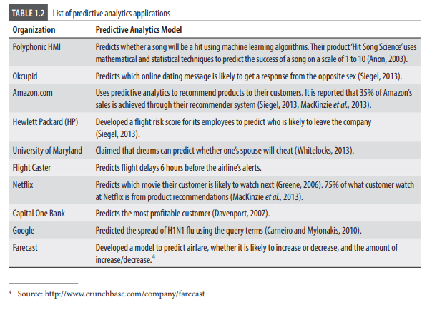
PRESCRIPTIVE ANALYTICS Every decision has a consequence. —Damon Darrel Prescriptive analytics is the highest level of analytics capability which is used for choosing optimal actions once an organization gains insights through descriptive and predictive analytics. In many cases, prescriptive analytics is solved as a separate optimization problem. Prescriptive analytics assists users in finding the optimal solution to a problem or in making the right choice/decision among several alternatives. Operations Research (OR) techniques form the core of prescriptive analytics. Apart from operations research techniques, machine learning algorithms, metaheuristics, and advanced statistical models are used in prescriptive analytics. Note that actionable items can be derived directly after descriptive and predictive analytics model development; however, they may not be the optimal action. For example, in a Business to Business (B to B) sales, the proportion of sales conversions to sales leads could be very low. The sales conversion period could be very long, as high as 6 months to one year. Predictive analytics such as logistics regression can be used for predicting the propensity to buy a product and actionable items (such as which customer to target) can be derived directly based on predicted probability to buy or using lift chart. However, the values of the sale are likely to be different, as are the profits earned from different customers. Thus, targeting customers purely based on probability to buy may not result in an optimal solution. Use of techniques such as binary integer programming will result in optimal targeting of customers that maximize total expected profit. That is, while actionable items can be derived from descriptive and predictive analytics, use of prescriptive analytics ensures optimal actions (choices or alternatives). The link between different analytics capability is shown in Figure 1.7. Ever since their introduction during World War II, OR models have been used in every sector of every industry. The list of prescriptive analytics applications is long and several companies across the world have benefitted from the use of prescriptive analytics tools. Coca-Cola Enterprises (CCE) is the largest distributor of Coca-Cola products. In 2005, CCE distributed 2 billion physical cases
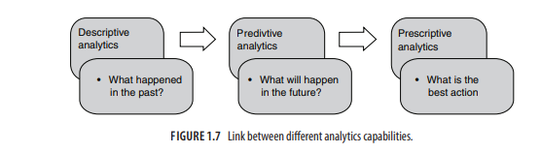
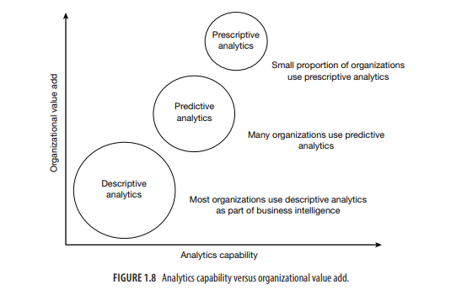
DESCRIPTIVE, PREDICTIVE, AND PRESCRIPTIVE ANALYTICS TECHNIQUES The most frequently used predictive analytics techniques are regression, logistic regression, classification trees, forecasting, K-nearest neighbours, Markov chains, random forest, boosting, and neural networks. The frequently used tools in prescriptive analytics are linear programming, integer programming, multi-criteria decision-making models such as goal programming and analytic hierarchy process, combinatorial optimization, non-linear programming, and meta-heuristics. In Table 1.3, we provide a brief description of some of these tools and the problems that are solved using these tools. We have highlighted a few tools that are frequently used by analytics companies.
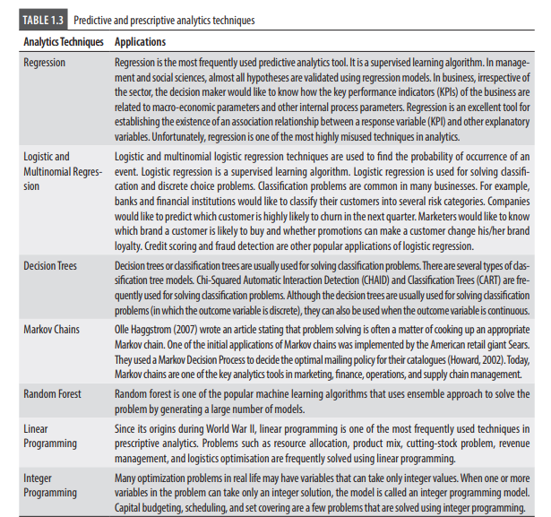
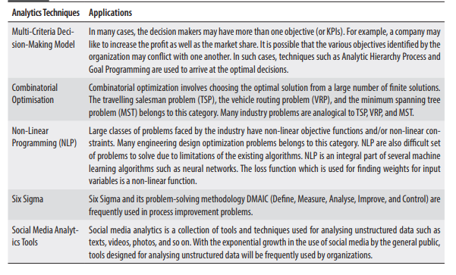
BIG DATA ANALYTICS The world is one big data problem. —Andrew McAfee Big data is a class of problems that challenge existing IT and computing technology and existing algorithms. Traditionally, big data is defined as a big volume of data (in excess of 1 terabyte) generated at high velocity with high variety and veracity. That is, big data is identified using 4 Vs, namely, volume, velocity, variety, and veracity which are defined as follows: 1. Volume is the size of the data that an organization holds. Typically, this can run into several petabytes (1015 bytes) or exabytes (1016 bytes). Organizations such as telecom and banking collect and store a large quantity of customer data. Data collected using satellite and other machine generated data such as data generated by health and usage monitoring systems fitted in aircrafts, weather and rain monitoring systems can run into several exabytes since the data is captured minute by minute. 2. Velocity is the rate at which the data is generated. For example, AT&T customers generated more than 82 petabytes of data traffic on a daily basis (Anon, 2016). 3. Variety refers to the different types of data collected. In the case of telecom, the different data types are voice calls, messages in different languages, video calls, use of Apps, etc. TABLE 1.3 (Continued) Analytics Techniques Applications Multi-Criteria Decision-Making Model In many cases, the decision makers may have more than one objective (or KPIs). For example, a company may like to increase the profit as well as the market share. It is possible that the various objectives identified by the organization may conflict with one another. In such cases, techniques such as Analytic Hierarchy Process and Goal Programming are used to arrive at the optimal decisions. Combinatorial Optimisation Combinatorial optimization involves choosing the optimal solution from a large number of finite solutions. The travelling salesman problem (TSP), the vehicle routing problem (VRP), and the minimum spanning tree problem (MST) belongs to this category. Many industry problems are analogical to TSP, VRP, and MST. Non-Linear Programming (NLP) Large classes of problems faced by the industry have non-linear objective functions and/or non-linear constraints. Many engineering design optimization problems belongs to this category. NLP are also difficult set of problems to solve due to limitations of the existing algorithms. NLP is an integral part of several machine learning algorithms such as neural networks. The loss function which is used for finding weights for input variables is a non-linear function. Six Sigma Six Sigma and its problem-solving methodology DMAIC (Define, Measure, Analyse, Improve, and Control) are frequently used in process improvement problems. Social media Social media analytics is a collection of tools and techniques used for analysing unstructured data such as texts, videos, photos, and so on. With the exponential growth in the use of social media by the general public, tools designed for analysing unstructured data will be frequently used by organizations. Introduction to Business Analytics 19 4. Veracity of the data refers to the quality issues. Especially in social media there could be biased or incorrect data, which can result in wrong inferences.
WEB AND SOCIAL MEDIA ANALYTICS social media and mobile devices such as smart phones are becoming an important source of data for all organizations, small and big. Social media is also an important marketing channel for marketers since it 20 Business Analytics helps to create a buzz or electronic word-of-mouth (WoM) effectively. Stelzner (2013) claimed that 86% of the marketers indicated that social media is important for their business. Stelzner (2013) identified the following questions as the most relevant for any marketers when dealing with social media engagement (also valid for mobile devices):
1. What is the most effective social media tactic?
2. What are the best ways to engage the customers with social media?
3. How to calculate the return on investment on social media engagement?
4. What are the best social media management tools?
5. How do we create a social media strategy for the organization?
“Machine learns with respect to a particular task T, performance metric P following experience E, if the system reliably improves its performance P at task T, following experience E”. Let the task T be a classification problem. To be more specific, consider customer’s propensity to buy a product. The performance P can be measured through several metrics such as overall accuracy, sensitivity, specificity, and area under the receive operating characteristic curve (AUC). The experience E is analogous to different classifiers generated in machine learning algorithms such as random forest (in random forest several trees are generated and each tree is used for classification of new case). Carbonell et al. (1983) list the following three dimensions of machine learning algorithms: 1. Learning strategies used by the system. 2. Knowledge or skill acquired by the system. 3. Application domain for which the knowledge is obtained. 22 Business Analytics Carbonell et al. (1983) classifies learning into two groups: knowledge acquisition and skill refinement. They give an example of knowledge acquisition as learning concepts in physics whereas skill refinement is similar to learning to play the piano or ride a bicycle. Machine learning algorithms imitate both knowledge acquisition as well as skill refinement process.

Descriptive analytics is the starting point of analytics-based solution to problems. It helps to understand the data and provide directions for predictive and prescriptive analytics. Business Intelligence (BI), which largely involves creating reports and business dashboard that led to actionable insights, is essentially a descriptive analytics exercise.

INTRODUCTION: EXPLORING INNER SPACE
“The sciences have developed in an order the reverse of what might have been expected. What was most remote from ourselves was first brought under the domain of law, and then, gradually, what was nearer: first the heavens, next the earth, then animal and vegetable life, then the human body, and last of all (as yet very imperfectly) the human mind.”
—Bertrand Russell, 1935
A Brave New World

We are in the midst of a revolution. For centuries science has made great strides in our understanding of the external observable world. Physics revealed the motion of the planets, chemistry discovered the fundamental elements of matter, biology has told us how to understand and treat disease. But during much of this time, there were still many unanswered questions about something perhaps even more important to us. That something is the human mind. What makes mind so difficult to study is that, unlike the phenomena described above, it is not something we can easily observe, measure, or manipulate. In addition, the mind is the most complex entity in the known universe.
To give you a sense of this complexity consider the following.
- The human brain is estimated to contain ten billion to one hundred billion individual nerve cells or neurons. Each of these neurons can have as many as ten thousand connections to other neurons. This vast web is the basis of mind, and gives rise to all of the equally amazing and difficult-to-understand mental phenomena such as perception, memory, and language.
- The past several decades have seen the introduction of new technologies and methodologies for studying this intriguing organ. We have learned more about the mind in the past half-century than in all the time that came before that. This period of rapid discovery has coincided with an increase in the number of different disciplines—many of them entirely new—that study mind. Since then, a coordinated effort among the practitioners of these disciplines has come to pass. This interdisciplinary approach has since become known as cognitive science. Unlike the science that came before, which was focused on the world of external, observable phenomena, or “outer space,” this new endeavor turns its full attention now to the discovery of our fascinating mental world, or “inner space.”

WHAT IS COGNITIVE SCIENCE?
- Cognitive science can be roughly summed up as the scientific interdisciplinary study of the mind. Its primary methodology is the scientific method, although as we will see, many other methodologies also contribute.
- A hallmark of cognitive science is its interdisciplinary approach. It results from the efforts of researchers working in a wide array of fields. These include philosophy, psychology, linguistics, artificial intelligence, robotics, and neuroscience. Each field brings with it a unique set of tools and perspectives.
- One major goal of cognitive science is to show that when it comes to studying something as complex as the mind, no single perspective is adequate.
- Instead, intercommunication and cooperation among the practitioners of these disciplines tell us much more.
- Cognitive science refers not so much to the sum of all these disciplines but to their intersection or converging work on specific problems.
- In this sense, cognitive science is not a unified field of study like each of the disciplines themselves, but a collaborative effort among researchers working in the various fields. The glue that holds cognitive science together is the topic of mind and, for the most part, the use of scientific methods.
- In order to really understand what cognitive science is all about we need to know what its theoretical perspective on the mind is. This perspective centers on the idea of computation, which may alternatively be called information processing.
- Cognitive scientists view the mind as an information processor. Information processors must both represent and transform information. That is, a mind, according to this perspective, must incorporate some form of mental representation and processes that act on and manipulate that information.
- Cognitive science is often credited with being influenced by the rise of the computer. Computers are of course information processors. Think for a minute about a personal computer.
- It performs a variety of information processing tasks. Information gets into the computer via input devices, such as a keyboard or modem. That information can then be stored on the computer, for example, on a hard drive or other disk.
- The information can then be processed using software such as a text editor. The results of this processing may next serve as output, either to a monitor or printer. In like fashion, we may think of people performing similar tasks. Information is “input” into our minds through perception—what we see or hear. It is stored in our memories and processed in the form of thought.
- Our thoughts can then serve as the basis of “outputs,” such as language or physical behavior. Of course, this analogy between the human mind and computers is at a very high level of abstraction.
- The actual physical way in which data is stored on a computer bears little resemblance to human memory formation. But both systems are characterized by computation. In fact, it is not going too far to say that cognitive scientists view the mind as a machine or mechanism whose workings they are trying to understand.

REPRESENTATION
- A concept stands for a single entity or group of entities. Single words are good examples of concepts.
- There are four crucial aspects of any representation (Hartshorne, Weiss & Burks, 1931– 1958).
  - First, a “representation bearer” such as a human or a computer must realize a representation.
  - Second, a representation must have content—meaning it stands for one or more objects.
  - The thing or things in the external world that a representation stands for are called referents. A representation must also be “grounded.” That is, there must be some way in which the representation and its referent come to be related.
  - Fourth, a representation must be interpretable by some interpreter, either the representation bearer him or herself, or somebody else. These and other characteristics of representations are discussed next. The fact that a representation stands for something else means it is symbolic.
We are all familiar with symbols. We know for instance that the symbol “$” is used to stand for money.
According to one view, a representation’s meaning is derived from the relationship between the representation and what it is about. The term that describes this relation is intentionality.
- Intentionality means “directed upon an object.” Mental states and events are intentional. They refer to some actual thing or things in the world. If you think about your brother, then the thought of your brother is directed toward him, not toward your sister, a cloud, or some other object.

DIGITAL REPRESENTATION
- In a digital representation, sometimes also known as a symbolic representation, information is coded in a discrete way with set values.
- It displays a separate number for each hour, minute, or year. There are distinct advantages to digital representations. They specify values exactly. The symbols used in digital representations, such as numbers, can be operated on by a more general set of processes than analog structures.
- In mathematics, a wide range of operators such as addition, division, or squaring can be applied to digital number representations. The results of these operations are new numbers that can themselves be transformed by additional operations.
- Language can serve as an example of a digital mental representation, and in fact verbal concepts seem to be the system of human symbolic representation that is most commonly used.
- The basic elements of written language are letters. These are discrete symbols that are combined according to a set of rules.
- The combinations, or words, have meaning and are themselves combined into other higher-order units, sentences, which also have semantic content. The rules by which these word elements are combined and transformed in language are called syntax.
- Syntax constitutes the set of permissible operations on the word elements. It is the elements themselves that are the mental representations. In the chapter on linguistics, we talk more about linguistic representations and syntax.

ANALOG REPRESENTATIONS
- Analog representations, in contrast, represent information in a continuous way. Information in an analog system can theoretically take on any value not limited by resolution.
- Resolution refers to the amount of detail contained in an analog representation. Representations with high resolution have correspondingly more information. An analog clock represents time through the movement of its various hands.
- Visual images are the best example of mental analog representations. Researchers in cognitive psychology have conducted numerous experiments that strongly suggest we represent visual information in an analog fashion. Stop reading for a moment and close your eyes.

THE DUAL-CODING HYPOTHESIS
- The use of both digital/symbolic and image representations collectively has been referred to as the dual-code hypothesis (Paivio, 1971). Alan Paivio believes that many ideas can be represented in either of these two forms interchangeably. This is especially true for a specific concrete concept, such as “elephant,” for which we can form a visual image or a verbal representation.
- However, there are some concepts for which a symbolic code seems more appropriate. Take the idea of “justice.” This is abstract, and although we could attach an image to it, such as that of a court building, there is no unambiguous and unique identifying image.
- Evidence in support of dual-code theory comes from studies in which better recall is demonstrated for words representing concrete concepts, as compared to words representing abstract concepts (Paivio, 1971).

PROPOSITIONAL REPRESENTATIONS
- Propositions are a third major category of representation, in addition to symbolic and imaginal codes (Pylyshyn, 1973).
- According to the propositional hypothesis, mental representations take the form of abstract sentence-like structures. Propositions are good at capturing the relationships between concepts.
- For example, the sentence “Mary looked at John” specifies a type of relationship between Mary and John, and that relationship can then be translated into either a verbal symbolic code, as in the actual form of a sentence, or an image code.
- A predicate calculus is a general system of logic that accurately expresses a large variety of assertions and modes of reasoning.
- The proposition “Mary looked at John” can be represented by a predicate calculus such as: [Relationship between elements] ([Subject element], [Object element]) where “Mary” is the subject element, “John” is the object element, and “looking” is the relationship between elements.
- What is nice about a predicate calculus is that it captures the essential logical structure of a complex idea independent of its actual elements. Any number of subjects, objects, and relationships can be inserted into the abstract format of a proposition. A proposition is thus believed to capture the basic meaning of a complex idea. This basic meaning, when translated back into a symbolic or visual code, can then be expressed in a variety of ways.

COMPUTATION
- As mentioned earlier, representations are only the first key component of the cognitive science view of mental processes.
- Representations by themselves are of little use unless something can be done with them. Having the concept of money doesn’t do much for us unless we know how to calculate a tip or can give back the correct amount of change to someone.
- In the cognitive science view, the mind performs computations on representations. It is therefore important to understand how and why these mental mechanisms operate. What sorts of mental operations does the mind perform?
- categories can be defined by the type of operation that is performed or by the type of information acted upon. An incomplete list of these operations would include sensation, perception, attention, memory, language, mathematical reasoning, logical reasoning, decision making, and problem-solving.

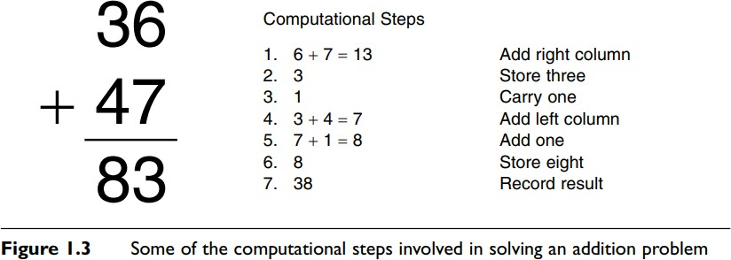

THE TRI-LEVEL HYPOTHESIS
Any given information process can be described at several different levels. According to the tri-level hypothesis, mental or artificial information-processing events can be evaluated on at least three different levels (Marr, 1982).
- The highest or most abstract level of analysis is the computational level. At this level, one is concerned with two tasks.
- The first is a clear specification of what the problem is. Taking the problem as it may have originally been posed, in a vague manner perhaps, and breaking it down into its main constituents or parts can bring about this clarity. It means describing the problem in a precise way such that the problem can be investigated using formal methods. It is like asking the questions:
- What exactly is this problem? What does this problem entail? The second task one encounters at the computational level concerns the purpose or reason for the process.
- The second task consists of asking: Why is this process here in the first place? Inherent in this analysis is the idea of adaptiveness—the idea that human mental processes are learned or have evolved to enable the human organism to solve a problem it faces. This is the primary explanatory perspective used in the evolutionary approach.
- Stepping down one level of abstraction, we can next inquire about the actual way in which an information process is carried out.
- To do this we need an algorithm, a formal procedure or system that acts on informational representations. It is important to note that algorithms can be carried out regardless of a representation’s meaning; algorithms act on the form, not the meaning, of the symbols they transform.
- One way to think of algorithms is that they are “actions” used to manipulate and change representations.
- Algorithms are formal, meaning they are well-defined. We know exactly what occurs at each step of an algorithm and how a particular step changes the information being acted on.
- A mathematical formula is a good example of an algorithm.
- A formula specifies how the data is to be transformed, what the steps are, and what the order of steps is. This type of description is put together at the algorithmic level, sometimes also called the programming level.
- It is equivalent to asking the question: What information-processing steps are being used to solve the problem? If we were to draw an analogy with computers, the algorithmic level is like software, because software contains instructions for the processing of data. The most specific and concrete type of description is formulated at the implementational level. Here we ask:
- Computers and humans can both perform addition, but do so in drastically different fashions. This is true at the implementational level obviously, but understanding the difference formally tells us much about alternative problem-solving approaches. It also gives us insights into how these systems might compute solutions to other novel problems that we might not understand.
- This partitioning of the analysis of information-processing events into three levels has been criticized as being fundamentally simplistic, since each level can in turn be further subdivided into levels (Churchland, Koch & Sejnowski, 1990).
- Figure 1.4 depicts one possible organization of the many structural levels of analysis in the nervous system.
- Starting at the top, we might consider the brain as one organizational unit; brain regions as corresponding to another organizational unit one step down in spatial scale; and then neural networks, individual neurons, and so on. Similarly, we could divide algorithmic steps into different sub-steps, and problems into sub-problems. To compound all this, it is not entirely clear how to map one level of analysis onto another.

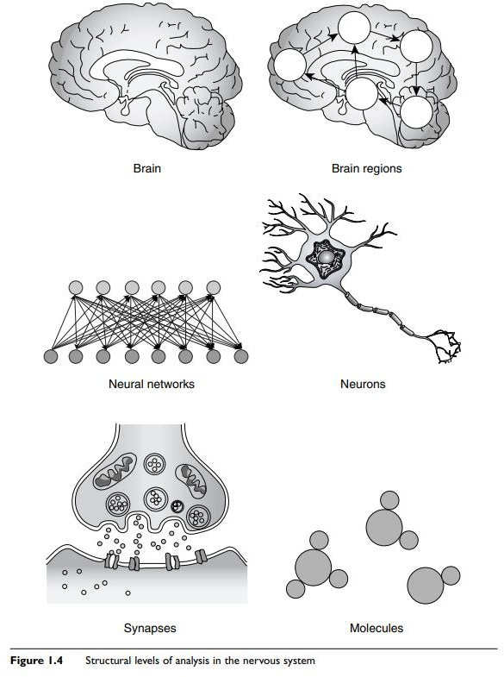

We may be able to clearly specify how an algorithm executes, but be at a loss to say exactly where or how this is achieved with respect to the nervous system.

THE CLASSICAL AND CONNECTIONIST VIEWS OF COMPUTATION
- A system is formal if it is syntactic or rule governed. The rules of language and mathematics are formal systems because they specify which types of allowable changes can be made to symbols.
- Formal systems also operate on representations independent of the content of those representations. In other words, a process can be applied to a symbol regardless of its meaning or semantic content.
- A symbol, as we have already indicated, is a form of representation and can assume a wide variety of forms. Manipulation here implies that computation is an active, embodied process that takes place over time.
- In the classical view, knowledge is represented locally, in the form of symbols. In the connectionist view knowledge is represented as a pattern of activation or weights that is distributed throughout a network.
- Processing style is also different in each approach. The classical view has processing occurring in discrete stages, whereas in connectionism, processing occurs in parallel through the simultaneous activation of nodes.
Some cognitive scientists downplay these differences, arguing that information processing occurs in both systems and that the tri-level hypothesis can be applied equally to both (Dawson, 1998).

SELF ASSESSMENT (2M)

- What is Cognitive Science?
- Differentiate Mind and Brain
- What is the role of Cognitive Scientist in solving complex and unstructured problems in real-time?
- What is taught?
- Illustrate the features of cognitive science.
- What is the need of computation in tri-level hypothesis?
- Define the term Algorithm in cognitive sense.

HISTORY OF COGNITIVE SCIENCE
- Cognitive Science: History- The roots of cognitive science extend back far in intellectual history, but its genesis as a collaborative endeavor of psychology, computer science, neuroscience, linguistics, and related fields lies in the 1950s. Its first major institutions (a journal and society) were established in the late 1970s. This history describes relevant developments within each field and traces collaboration between the fields in the last half of the twentieth century.
- A key contributor to the emergence of cognitive science, psychologist George Miller, dates its birth to September 11, 1956, the second day of a Symposium on Information Theory at MIT.
- Computer scientists Allen Newell and Herbert Simon, linguist Noam Chomsky, and Miller himself presented work that would turn each of their fields in a more cognitive direction. Miller left the symposium ‘with a strong conviction, more intuitive than rational, that human experimental psychology, theoretical linguistics, and the computer simulation of cognitive processes were all pieces from a larger whole, and that the future would see a progressive elaboration and coordination of their shared concerns’ (Miller 1979).
- This early conference illustrates an enduring feature of cognitive science—it is not a discipline in its own right, but a multidisciplinary endeavor. Although a few departments of cognitive science have been created at universities in subsequent decades, most of its practitioners are educated and spend their careers in departments of the contributing disciplines. The relative prominence of these disciplines has varied over the years.
- Computer science and psychology have played a strong role throughout. Neuroscience initially was strong, but in the years immediately following the 1956 conference its role declined as that of linguistics dramatically increased. By the 1970s, such disciplines as philosophy, sociology, and anthropology were making distinctive contributions. Recently, with the emergence of cognitive neuroscience, neuroscience has once again become a central contributor.

THE INTERDISCIPLINARY PERSPECTIVE OF COGNITIVE SCIENCE
There is an old fable about five blind men who stumble upon an elephant (see Figure 1.5). Not knowing what it is, they start to feel the animal. One man feels only the elephant’s tusk and thinks he is feeling a giant carrot. A second man,

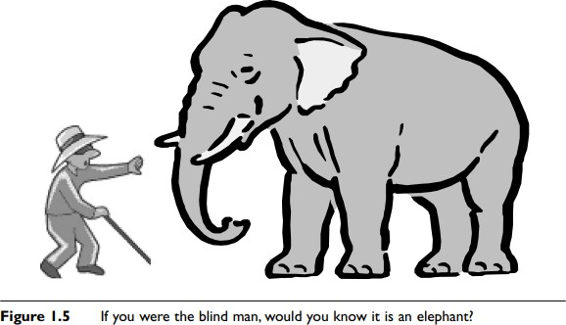

feeling the ears, believes the object is a big fan. The third feels the trunk and proclaims it is a pestle, while a fourth touching only the leg believes it is a mortar. The fifth man, touching the tail, has yet another opinion: he believes it to be a rope. Obviously, all five men are wrong in their conclusions because each has only examined one aspect of the elephant. If the five men had gotten together and shared their findings, they may have easily pieced together what kind of creature it was. This story serves as a nice metaphor for cognitive science.

- We can think of the elephant as the mind and the blind men as researchers in different disciplines in cognitive science. Each individual discipline may make great strides in understanding its particular subject matter, but, if it cannot compare its results to those of other related disciplines, may miss out on understanding the real nature of what it is that is being investigated.
- The key, then, to figuring out something as mysterious and complex as mind is communication and cooperation among disciplines. This is what’s meant when one talks about cognitive science—not the sum of each of the disciplines or approaches, but their union.
- Recent years have seen an increase in this cooperation. A number of major universities have established interdisciplinary cognitive science centers, where researchers in such diverse areas as philosophy, neuroscience, and cognitive psychology are encouraged to work together on common problems. Each area can then contribute its unique strength to the phenomenon under study.
- The philosophers can pose broad questions and hypotheses, the neuroscientists can measure physiological performance and brain activity, while the cognitive psychologists can design and carry out experiments.
- The consequent exchange of results and ideas then leads to fruitful synergies between these disciplines, accelerating progress with respect to finding solutions to the problem and yielding insights into other research questions. We have alluded to some of the different approaches in cognitive science. Because this book is about explaining each approach and its major theoretical contributions, it is worth describing each now in terms of its perspective, history, and methodology. In the following sections we will also provide a brief preview of the issues addressed by each approach.

PHILOSOPHICAL APPROACH

Philosophy is the oldest of all the disciplines in cognitive science. It traces its roots back to the ancient Greeks.
Philosophers have been active throughout much of recorded human history, attempting to formulate and to answer basic questions about the universe. This approach is free to study virtually any sort of important question on virtually any subject, ranging from the nature of existence to the acquisition of knowledge, to politics, ethics, and beauty.
Philosophers of mind narrow their focus to specific problems concerning the nature and the characteristics of mind. They might ask questions like: What is mind? How do we come to know things?
How is mental knowledge organized? The primary method of philosophical inquiry is reasoning, both deductive and inductive. Deductive reasoning involves the application of the rules of logic to statements about the world. Given an initial set of statements assumed to be true, philosophers can derive other statements that logically must be correct.
For example, if the statement “College students’ study three hours every night” is true and the statement “Mary is a college student” is true, we can then conclude that “Mary will study three hours every night.”
Philosophers also engage in inductive reasoning. They make observations about specific instances in the world, notice commonalities among them, and draw conclusions.
An example of inductive reasoning would be: “Whiskers the cat has four legs,” “Scruffy the cat has four legs,” therefore “All cats have four legs.” However, philosophers do not use a systematic form of induction known as the scientific method. That is employed within the other cognitive science disciplines.
With respect to the mind-body problem, philosophers wrangle over what exactly a mind is. Is the mind something physical like a rock or a chair, or is it nonphysical?
Can minds exist only in brains or can they emerge from the operation of other complex entities such as computers? In the free will–determinism debate we explore whether our actions can ever be completely known and/or predicted beforehand.
The knowledge acquisition problem deals with how we come to know things. Is knowledge a product of one’s genetic endowment or does it arise through one’s interaction with the environment?
How much does each of these factors contribute to any given mental ability? We also look into one of the most fascinating and enigmatic mysteries of mind, that of consciousness. What is consciousness? Are we really conscious at all?

THE PSYCHOLOGICAL APPROACH
Compared to philosophy, psychology is a relatively young discipline. It can be considered to be old though, particularly when it is compared to some of the more recent newcomers to the cognitive science scene, for example, artificial intelligence and robotics. Psychology arose in the late 19th century and was the first discipline in which the scientific method was applied exclusively to the study of mental phenomena.
Early psychologists established experimental laboratories that would enable them to catalog mental ideas and to investigate various mental capacities, such as vision and memory. Psychologists apply the scientific method to both mind and behavior.
That is, they attempt to understand not just internal mental phenomena, such as thoughts, but also the external behaviors that these internal phenomena can give rise to.
The scientific method is a way of getting hold of valid knowledge about the world. One starts with a hypothesis or idea about how the world works and then designs an experiment to see if the hypothesis has validity.
In an experiment, one essentially makes observations under a set of controlled conditions.
The resulting data then either support or fail to support the hypothesis.
The field of psychology is broad and encompasses many subdisciplines, each one having its unique theoretical orientations.
Each discipline has a different take on what mind is. The earliest psychologists, that is, the voluntarists and structuralists, viewed the mind as a kind of test tube in which chemical reactions between mental elements took place. In contrast, functionalism viewed mind not according to its constituent parts, but according to what its operations were—what it could do.
The Gestaltists again went back to a vision of mind as composed of parts, but emphasized that it was the combination and interaction of the parts, which give rise to new wholes, that was important.
Psychoanalytic psychology conceives of mind as a collection of competing entities, while behaviorism sees it as a device that maps stimuli onto behaviors.

THE COGNITIVE APPROACH
Starting in the 1960s a new form of psychology arrived on the scene. Known as cognitive psychology, it came into being in part as a backlash against the behaviorist movement and its profound emphasis on behavior.
Cognitive psychologists placed renewed emphasis on the study of internal mental operations. They adopted the computer as a metaphor for mind, and described mental functioning in terms of representation and computation. They believed that the mind, like a computer, could be understood in terms of information processing.
The cognitive approach was also better able to explain phenomena such as language acquisition, for which behaviorists did not have good accounts. At around the same time, new technologies that allowed better measurement of mental activity were being developed.
This promoted a movement away from the behaviorist’s emphasis on external observable behaviors toward the cognitive scientist’s emphasis on internal functions, as these could, for the first time, be observed with reasonable precision.
Inherent in the cognitive approach is the idea of modularity. Modules are functionally independent mental units that receive inputs from other modules, perform a specific processing task, and pass the results of their computation onto yet additional modules.
The influence of the modular approach can be seen in the use of process models or flow diagrams. These depict a given mental activity via the use of boxes and arrows, where boxes depict modules and arrows the flow of information among them.
The techniques used in this approach are the experimental method and computational modeling. Computational modeling involves carrying out a formal (typically software based) implementation of a proposed cognitive process.
Researchers can run the modeling process so as to simulate how the process might operate in a human mind. They can then alter various parameters of the model or change its structure in an effort to achieve results as close as possible to those obtained in human experiments. This use of modeling and comparison with experimental data is a unique characteristic of cognitive psychology and is also used in the artificial intelligence and network approaches.
Cognitive psychologists have studied a wide variety of mental processes. These include pattern recognition, attention, memory, imagery, and problem solving.

THE NEUROSCIENCE APPROACH
Brain anatomy and physiology have been studied for quite some time. Recent times however have seen tremendous advances in our understanding of the brain, especially in terms of how neuronal processes can account for cognitive phenomena.
The general study of the brain and endocrine system is called neuroscience. The attempt to explain cognitive processes in terms of underlying brain mechanisms is known as cognitive neuroscience.
Neuroscience, first and foremost, provides a description of mental events at the implementational level. It attempts to describe the biological “hardware” upon which mental “software” supposedly runs.
However, as discussed above, there are many levels of scale when it comes to describing the brain, and it is not always clear which level provides the best explanation for any given cognitive process.
Neuroscientists, however, investigate at each of these levels. They study the cell biology of individual neurons and of neuron-to-neuron synaptic transmission, the patterns of activity in local cell populations, and the interrelations of larger brain areas.
A reason for many of the recent developments in neuroscience is, again, the development of new technologies. Neuroscientists employ a wide variety of machines to measure the performance of the brain at work. These include positron emission tomography (PET) scanners, computerized axial tomography (CAT) scanners, and magnetic resonance imaging (MRI) machines.
Studies that use these devices have participants perform a cognitive task; the brain activity that is concurrent with the performance of the task is recorded. For example, a participant may be asked to form a visual image of a word that appears on a computer screen.
The researchers can then determine which parts of the brain became active during imagery and in what order. Neuroscientists use other techniques as well. They study brain-damaged patients and the effects of lesions in laboratory animals, and use single- and multiple-cell recording techniques.

THE NETWORK APPROACH
The network approach is at least partially derived from neuroscience. In this perspective, mind is seen as a collection of individual computing units.
These units are connected to one another and mutually influence one other’s activity via the connections.
Although each of the units is believed to perform a relatively simple computation, for example, a neuron’s either firing or not firing, the connectivity of the units can give rise to representational and computational complexity.
The first involves the construction of artificial neural networks. Most artificial neural networks are computer software simulations that have been designed to mimic the way actual brain networks operate, or the functioning of neural cell populations. Artificial neural networks that can perform arithmetic, learn concepts, and read out loud now exist.
A wide variety of network architectures have developed over the last thirty years. The second part of the network chapter is more theoretical and focuses on knowledge representation—on how meaningful information may be mentally coded and processed.
In semantic networks, nodes standing for concepts are connected to one another in such a way that activation of one node causes activation of other related nodes.
- Semantic networks have been constructed to explain how conceptual information in memory is organized and recalled. They are often used to predict and explain data obtained from experiments with human participants in cognitive psychology.

THE EVOLUTIONARY APPROACH
The theory of natural selection proposed by Charles Darwin in 1859 revolutionized our way of thinking about biology. Natural selection holds that adaptive features enable the animals that possess them to survive and pass these features on to future generations.
The environment in this view is seen as selecting from among a variety of traits those that serve a functional purpose. The evolutionary approach can be considered in a quite general way and used to explain phenomena outside of biology.
The field of evolutionary psychology applies selection theory to account for human mental processes.
It attempts to elucidate the selection forces that acted on our ancestors and how those forces gave rise to the cognitive structures we now possess. Evolutionary psychologists also adopt a modular approach to mind.
In this case, the modules correspond to “favored” cognitive capacities that were used by ancestors successful at solving certain problems.
Evolutionary theories have been proposed to account for experimental results across a wide range of capacities, from categorization to memory, to logical and probabilistic reasoning, language, and cognitive differences between the sexes.
A variant on this theme is evolutionary computing, in which the rules of evolution are applied to create successful computer algorithms. An offshoot of this form of computing is artificial life. These are software simulations that mimic biological ecosystems. There is also neural Darwinism, which uses evolution to explain the formation of neural circuits.

THE LINGUISTIC APPROACH
Linguistics is an area that focuses exclusively on the domain of language. It is concerned with all questions concerning language ability, such as: What is language? How do we acquire language?
What parts of the brain underlie language use? As we have seen, language is a topic studied within other disciplines, for example, cognitive psychology and neuroscience. Because so many different researchers in different disciplines have taken on the problem of language, we consider it here as a separate discipline, united more by topic than by perspective or methodology.
Part of the difficulty in studying language is the fact that language itself is so complex. Much research has been devoted to understanding its nature. This work looks at the properties all languages share, the elements of language, and how those elements are used during communication.
Other foci of linguistic investigation center on primate language use, language acquisition, deficits in language acquisition caused by early sensory deprivation or brain damage, the relationship between language and thought, and the development of speech recognition systems.
Linguistics, perhaps more than any other perspective discussed here, adopts a very eclectic methodological approach.
Language researchers employ experiments and computer models, study brain-damaged patients, track how language ability changes during development, and compare diverse languages.

THE ARTIFICIAL INTELLIGENCE APPROACH
Researchers have been building devices that attempt to mimic human and animal function for many centuries. But it is only in the past few decades that computer scientists have seriously attempted to build devices that mimic complex thought processes. This area is now known as artificial intelligence (AI).
Researchers in AI are concerned with getting computers to perform tasks that have heretofore required human intelligence. As such they construct programs to do the sorts of things that require complex reasoning on our part. AI programs have been developed that can diagnose medical disorders, use language, and play chess.
AI secondarily gives us insights into the function of human mental operations. Designing a computer program that can visually recognize an object often proves useful in understanding how we may perform the same task ourselves. An even more exciting outcome of AI research is that someday we may be able to create an artificial person who will possess all or many of the features that we consider uniquely human, such as consciousness, the ability to make decisions, and so on.
It is the development of computer algorithms and their testing, their comparison with empirical data or performance standards, and their subsequent modification that constitute the methodology of the AI perspective. Not all computer programs are alike, however.
Researchers have employed a wide range of approaches. An early attempt at getting computers to reason involved the application of logical rules to propositional statements. Later on, expert systems, scripts, and fuzzy logic procedures, among others, were used.

THE ROBOTICS APPROACH
Finally, we consider robotics. Robotics may be considered a familial relation to AI and has appeared on the scene as a formal discipline just as recently. Whereas AI workers build devices that “think,” robotics researchers build machines that must also “act.”
Investigators in this field build autonomous or semi-autonomous mechanical devices that have been designed to perform a physical task in a real-world environment.
Examples of things that robots can do presently include navigating around a cluttered room, welding or manipulating parts on an assembly line, and defusing bombs. The robotics approach has much to contribute to cognitive science and to theories of mind. Robots, like people and animals, must demonstrate successful goal-oriented behaviors under complex, changing, and uncertain environmental conditions.
Robotics therefore helps us to think about the kinds of minds that underlie and produce such behaviors.
The hierarchical paradigm offers a “top down” perspective, according to which a robot is programmed with knowledge about the world. The robot then uses this model or internal representation to guide its actions.
The reactive paradigm, on the other hand, is “bottom up.” Robots that use this architecture respond in a simple way to environmental stimuli: they react reflexively to a stimulus input and there is little in the way of intervening knowledge.

IN DEPTH: CATEGORIES OF MENTAL REPRESENTATION
We have said that there are three broad classes of mental representation— digital, analog, and propositional—each having its own characteristics, and we gave examples of each. However, the history of research in cognition suggests that there are also numerous forms of mental representation.
Paul Thagard, in Mind: Introduction to Cognitive Science (2000), proposes four. These are concepts, propositions, rules, and analogies. Although some of these have already been alluded to and are described elsewhere in the book, they are central to many ideas in cognitive science.
It is therefore useful to sketch out some of their major characteristics here. A concept is perhaps the most basic form of mental representation. A concept is an idea that represents things we have grouped together.
The concept “chair” does not refer to a specific chair, such as the one you are sitting in now, but is more general than that. It refers to all possible chairs no matter what their colors, sizes, and shapes.
Concepts need not refer to concrete items. They can stand for abstract ideas, for example, “justice” or “love.”
Concepts can be related to one another in complex ways. They can be related in a hierarchical fashion, where a concept at one level of organization stands for all members of the class just below it.
“Golden retrievers” belongs to the category of “dogs,” which in turn belongs to the category of “animals.”
The question of whether concepts are innate or learned is discussed in the philosophical approach chapter. The artificial intelligence chapter outlines the use of structures called frames as a means of representing conceptual knowledge.
A proposition is a statement or assertion typically posed in the form of a simple sentence. An essential feature of a proposition is that it can be proved true or false. For instance, the statement “The moon is made out of cheese” is grammatically correct and may
represent a belief that some people hold, but it is a false statement.
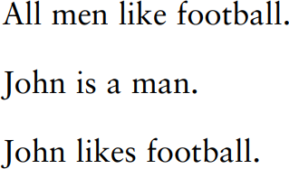
We can apply the rules of formal logic to propositions to determine the validity of those propositions. One logical inference is called a syllogism. A syllogism consists of three propositions. The first two are premises and the last is a conclusion. Take the following syllogism
Obviously, the conclusion can be wrong if either of the two premises is wrong. If it is not true that all men like football, then it might not be true that John likes football, even if he is a man.
If John is not a man, then he may or may not like football, assuming all men like it. Syllogistic reasoning of this sort is the same as deductive reasoning, mentioned earlier. You may have noticed that propositions are representations that incorporate concepts.
The proposition “All men like football” incorporates the concepts “men” and “football.”
Propositions are more sophisticated representations than concepts because they express relationships, sometimes very complex ones, between concepts.
The rules of logic are best thought of as computational processes that can be applied to propositions in order to determine their validity. However, logical relations between propositions may themselves be considered a separate type of representation.
The evolutionary approach chapter provides an interesting account of why logical reasoning, which is difficult for many people, is easier under certain circumstances. Logic is not the only system for performing operations on propositions. Rules do this as well.
A production rule is a conditional statement of the form: “If x, then y,” where x and y are propositions. The “if” part of the rule is called the condition. The “then” part is called the action. If the proposition that is contained in the condition (x) is true, then the action that is specified by the second proposition (y) should be carried out, according to the rule. The following rules help us drive our cars:

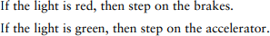
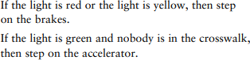
Notice that, in the first rule, the two propositions are “the light is red” and “step on the brakes.” We can also form more complex rules by linking propositions with “and” and “or” statements
The “or” that links the two propositions in the first part of the rule specifies that if either proposition is true, the action should be carried out. If an “and” links these two propositions, the rule specifies that both must be true before the action can occur.
Rules bring up the question of what knowledge really is. We usually think of knowledge as factual. Indeed, a proposition such as “Candy is sweet,” if validated, does provide factual information.
The proposition is then an example of declarative knowledge. Declarative knowledge is used to represent facts. It tells us what is and is demonstrated by verbal communication.
Procedural knowledge, on the other hand, represents skill. It tells us how to do something and is demonstrated by action. If we say that World War II was fought during the period 1939–1945, we have demonstrated a fact learned in history class.
If we ski down a snowy mountain slope in the winter, we have demonstrated that we possess a specific skill. It is therefore very important that information-processing systems have some way of representing actions if they are to help an organism or machine to perform those actions.
Rules are one way of representing procedural knowledge. We discuss two cognitive rule- based systems, the Atomic Components of Thought (ACT) and SOAR models, in the cognitive approach chapters. Another specific type of mental representation is the analogy, although, as is pointed out below, the analogy can also be classified as a form of reasoning.
Thinking analogically involves applying one’s familiarity with an old situation to a new situation.
Suppose you had never ridden on a train before, but had taken buses numerous times. You could use your understanding of bus riding to figure out how to take a ride on a train.
Applying knowledge that you already possess and that is relevant to both scenarios would enable you to accomplish this. Based on prior experience, you would already know that you have to first determine the schedule, perhaps decide between express and local service, purchase a ticket, wait in line, board, stow your luggage, find a seat, and so on.

Analogies are a useful form of representation because they allow us to generalize our learning. Not every situation in life is entirely new. The application of the analogical
approach in artificial intelligence is called case-based reasoning

SELF ASSESSMENT

- Explain the Interdisciplinary Study of Cognitive Science? (4M)
OR
- Elaborate the history of Cognitive Science (4/8M)

DEVELOPMENT AND METHODOLOGICAL CONCERNS IN PHILOSOPHY

Philosophy as Methodology
- The general concept of methodology. The world presents us with a picture of an infinite diversity of properties, connections and events. This kaleidoscope of impressions must be permeated by an organising principle, a certain method, that is to say, by certain regulative techniques and means of the practical and theoretical mastering of reality.
- Practical and theoretical activities follow different methods. The former indicate the ways of doing things and corresponding human skills that have been historically formed and socially established in the instruments of labour. The latter characterise the modes of activity of the mind resulting in the finding truth and the correct, rational solution of problems.
- A methodology is a system of principles and general ways of organising and structuring theoretical and practical activity, and also the theory of this system.
- Genetically methods go back far into the past, when our distant ancestors were acquiring, generalising and handing down to new generations their skills and means of influencing nature, the forms of organising labour and communication. As philosophy emerged, methodology became a special target of cognition and could be defined as a system of socially approved rules and standards of intellectual and practical activity.
- These rules and standards had to be aligned with the objective logic of events, with the properties and laws of phenomena. The problems of accumulating and transmitting experience called for a certain formalisation of the principles and precepts, the techniques and operations involved in activity itself.
- With the development of production, technology, art, and the elements of science and culture, methodology becomes the target of theoretical thought, whose specific form is the Philosophical comprehension of the principles of organisation and regulation of cognitive activity, its conditions, structure and content.
- For example, in the work of Heraclitus "knowledge of many things" is contrasted to reason, the latter being a Particularly reliable means of understanding the dialectics of the universe--the universal Logos--and to be distinguished from the diversity of the "opinions" and legends acquired by unreliable means.
- The rules of reasoning, of effective proof, the role of language as a means of cognition were the subject of special inquiry in the philosophy of the Greek Sophists (Protagoras and others).
- Socrates, Plato and Aristotle occupy a special place in discussion of the problems of methodology. Socrates, for example, gave priority to the dialogical nature of thinking as the joint attainment of truth through collation of different notions and concepts, their comparison, analysis, definition and so on.
- Aristotle defined the facts , information based on classification concept from micro-organisms and defined knowledge base
- He regarded his theory of Proceeding by means of induction from vague notions to clearly defined general concepts as a method of Perfecting the art of living, of achieving virtue; logical operations were subordinated to ethical aims.
- According to Socrates, the acquisition of true knowledge should serve action with a moral purpose.
- The purpose should be determined by means of appropriately organised work of the intellect. This Socratic principle had a deep influence on various trends in the evolution of methodology, especially on the teaching of Plato, who developed a dialectic of concepts and categories the purpose of which was to find the principle in everything. In order to achieve this, our thoughts should move according to the objective logic of the objects under consideration as the embodiments of incorporeal essences. The world of these essences, or ideas, was also regarded as a realm of beauty, of the good which the soul could attain through strenuous effort.
- Assuming like Plato that the object of true knowledge was the universal, Aristotle taught that this universal was to be discovered by investigating individual, empirically given things.
- The methodology of such research is set forth in Aristotle's logic, which closely analyses the principles for defining a term or constructing a statement, the rules of inference and proof, the role of induction and deduction in attaining truth, and so on.
- Aristotle's aesthetics expounds the principles of creativity and analysis in works of art. He also gives us a methodologically important elaboration of the theory of categories as the organising forms of cognition and their dialectics.
- Until modern times, however, the problems of methodology had no independent place in the system of knowledge and arose only in the context of logical and natural philosophical arguments. Scientific progress is not limited to the accumulation of knowledge. It is also a process of evolving new means of seeking knowledge.
- The rapid advance of natural science called for radical changes in methodology. This need was reflected in new principles of methodology and corresponding philosophical ideas, both rationalistic and empirical, directed against scholasticism.
- The principles of mechanics marked a breakthrough in methodology. According to Galileo, scientific knowledge, by uniting the inductive and deductive methods, should be based on planned, accurate mental and practical experiment.
- In Descartes the problem of methodology is central. Methodology is required to establish on what basis and by what methods new knowledge may be obtained. Descartes worked out the rules of the rationalistic method, the first rule being the demand that only propositions that are clearly and distinctly comprehensible may be accepted as true.
- The first principles are axiomatic knowledge, that is, ideas perceived intuitively by reason, without any proof. From these immediately perceived propositions new knowledge is deduced by means of deductive proof. This assumes the breaking down of complex problems into more specific and comprehensible problems and a strictly logical advance from the known to the unknown.
- Another line in methodology was represented at this time by English empiricism, which sought to devise modes of thought that would help to build a strictly experimental science guided by proofs of scientific truths arrived at through induction.
- The limitations of both trends were revealed by German classical philosophy, which produced a searching analysis of the conditions of cognition, its forms and organising principles. In contrast to mechanistic methodology, which metaphysically interpreted the ways and means of cognition, classical German Philosophy developed a dialectical methodology in idealistic forms.
- The relationship between theory and method. Whereas theory is the result of a process of cognition that reproduces a certain fragment of existence, methodology is a way of obtaining and building up such knowledge. Theory characterises knowledge itself, its structure, content and the degree to which it corresponds to the object; method characterises the activity involved in acquiring knowledge. It characterises the conditions for obtaining true knowledge.
- In practice, the distinction between theory and method may sometimes be functional: having taken shape as a theoretical result of past inquiry, method acts as the point of departure and condition for further investigation. Thus the law of the conservation of matter and energy as a theoretical principle expressing the fundamental condition for the existence of the world is simultaneously a methodological requirement for the investigation of any phenomenon.
- The methodological principle of the determinist explanation of the world is the organising principle of the corresponding physical, biological and social theories. After being tested by social practice, these theories in their turn may perform a methodological function, that is, serve as a guiding principle in further research.
- The need thus arises not only to pool the efforts of specialists in various fields, but also to combine scientific data in situations where there is in principle no complete or definite information about the object as a whole, as a system.
- Modern science is becoming more abstract and lends itself more easily to mathematical methods of research. Particularly relevant are the problems of interpreting the results of research performed with an extensive use of formalisation techniques. This has led to the special elaboration of methods interpretation and modelling.
- There are several classifications of methodological knowledge. One of the most popular is the division of methodology into substantive and formal methodology. The former includes such problems as the structure of scientific knowledge in general and scientific theory in particular, the laws of the generation, functioning and mutation of scientific theories, the conceptual framework of science and its separate disciplines, the definition of the explanatory patterns accepted in science, the structure and Operational composition of the methods of science, the conditions and criteria of scientificalness.
- The formal aspects ,of methodology are related to analysis of the language of science, the formal structure of scientific explanation, description and analysis of formal and formalised methods of research, particularly the methods of constructing scientific theories and conditions of their logical truth, the typology of systems of knowledge, and so on. It was the elaboration of this set of problems that raised the question of the logical structure of scientific knowledge and the development of a methodology of science as an independent field of knowledge.
- This field embraces the whole diversity of methodological and methodic principles and techniques, operations and forms of constructing scientific knowledge, Its highest and definitive level is the philosophical methodology, whose guiding principles organise methodological work both at the general scientific level (including the logico-methodological apparatus applicable to many disciplines) and at the specialised scientific level, Where special methods of research and derivative specific methodical systems are devised and applied.
- Method is concretised methodology. Through the method of the concrete science it reaches the research desk. The concrete sciences, which are specific in relation to philosophy, may in their turn be methodological in relation to the narrower fields of their specific sphere of knowledge.
- For example, general biology arms botany, zoology and other narrower disciplines with general methods of research. Relying on Philosophy, general biology works out the methodological problems related to all the departments of biological science. This principle is to be found in other sciences as well.
- According to another classification, methods are divided into philosophical, general scientific, and special scientific methods. Yet another classification relies on different methods of qualitative and quantitative study of reality. The distinction between methods depending on the forms of causality—determinist and probability methods—is of considerable importance in modern science.
- For example, in biology dialectics is seen through the prism of general scientific methods (systems analysis, the principles of self-regulation, etc.), in specific research projects through apply ing special scientific methods and systems of methods (electronic microscopy, the method of tagged atoms, etc.). One or another method makes it possible to know only separate aspects of the object of research. In order to comprehend all the essential aspects of the object, there must be complementarity of methods.
- The whole system of methodological knowledge necessarily involves a world-view interpretation of the basis of the research and its results. It should be stressed that general methodology is always at work in the brain of every scientist but, as a rule, it is kept in obscurity, as the intellectual background of a searching mind. This obscurity is sometimes so complete that the scientist may even deny that he acts according to any philosophical methodology, and insist that he is in general free of any philosophy. But this is merely an illusion of the consciousness.
- What makes us human? Less grandiosely: what distinguishes human cognition and action from the behavior of other animals?1 We talk, accumulate culture, cooperate with strangers, and other things that non-human animals do not clearly replicate. It seems plausible that some unique cognitive capacities might account for this peculiar behavior. Here the trouble starts: scientific inquiry keeps showing us how smart animals are and how animal we are.
- Specific claims to cognitive specialness tend to wilt under scientific scrutiny, and puzzles emerge from the most cursory survey of findings. What is supposed to set us apart, anyway?
- Is it possession of first order mental states, like beliefs and desires? Most likely not.
- A capacity to reflect on our own mental states? No: rats can do that, too. Recursive syntax, and an ability to learn syntactic rules? Birds have both, apparently. An ability to deploy concepts? Humans have the most conceptual acumen, but other animals acquire concepts, too. Findings like these are provisional: interpreting experimental results is not straightforward, and we can dispute any given conclusion. The trend, however, seems unmistakable: prospects for human specialness are dimming, not brightening.
- There is tension, then, between the claim that we are special and the naturalistic understanding of human and animal cognition that we achieve through scientific inquiry. We cannot resolve this tension by appealing to some putative non-natural, uniquely human characteristic. A characteristic is “non-natural” in the sense I intend just in case it is impossible to account for it within the scope of standard scientific inquiry, which supplies what I take to be paradigmatically naturalistic explanations.
- Humans, according to Aristotle, are capable of some special brand of cognition. Call this RATIONAL cognition, and say that animals capable of rational cognition have RATIONALITY. RATIONALITY (which Aristotle variously refers to as nous or, in some important cases, logos) 8 grants the creature a set of special cognitive capabilities. How are we to characterize these capabilities? What are we looking for? It is conventional to assume that we should understand RATIONALITY in terms of certain high-level cognitive achievements, such as scientific knowledge (epist^em^e), understanding (nous) 9 and practical wisdom (phron^esis).
- Aristotle devotes much attention to such cognition, which makes it tempting to conclude that they comprise the only human cognition that he cares about.
SELF ASSESSMENT
- Explain the Developmental and methodological concerns of philosophy. (8M)
OR
Explain the Philosophy of Aristotle to knowledge system.
OR
Illustrate the key role functioning of Philosophy in Cognitive science.
Psychological Antecedents of Cognitive Psychology
Cognitive psychology has roots in many different ideas and approaches. The approaches that will be examined include early approaches such as structuralism and functionalism, followed by a discussion of associationism, behaviorism, and Gestalt psychology.
Early Dialectics in the Psychology of Cognition Only in recent times did psychology emerge as a new and independent field of study. It developed in a dialectical way.
Typically, an approach to studying the mind would be developed; people then would use it to explore the human psyche. At some point, however, researchers would find that the approach they learned to use had some weaknesses, or they would disagree with some fundamental assumptions of that approach. They then would develop a new approach.
Future approaches might integrate the best features of past approaches or reject some or even most of those characteristics. In the following section, we will explore some of the ways of thinking early psychologists employed and trace the development of psychology through the various schools of thinking. Understanding the Structure of the Mind: Structuralism An early dialectic in the history of psychology is that between structuralism and functionalism (Leahey, 2003; Morawski, 2000). Structuralism was the first major school of thought in psychology. Structuralism seeks to understand the structure (configuration of elements) of the mind and its perceptions by analyzing those perceptions into their constituent components (affection, attention, memory, sensation, etc.).
Consider, for example, the perception of a flower. Structuralists would analyze this perception in terms of its constituent colors, geometric forms, size relations, and so on. In terms of the human mind, structuralists sought to deconstruct the mind into its elementary components; they were also interested in how those elementary components work together to create the mind. Wilhelm Wundt (1832–1920) was a German psychologist whose ideas contributed to the development of structuralism. Wundt is often viewed as the founder of structuralism in psychology (Structuralism, 2009).Wundt used a variety of methods in his research. One of these methods was introspection. Introspection is a deliberate looking inward at pieces of information passing through consciousness. The aim of introspection is to look at the elementary components of an object or process. The introduction of introspection as an experimental method was an important change in the field because the main emphasis in the study of the mind shifted from a rationalist approach to the empiricist approach of trying to observe behavior in order to draw conclusions about the subject of study. In experiments involving introspection, individuals reported on their thoughts as they were working on a given task. Researchers interested in problem solving could ask their participants to think aloud while they were working on a puzzle so the researchers could gain insight into the thoughts that go on in the participants’ minds. In introspection, then, we can analyze our own perceptions. The method of introspection has some challenges associated with it. First, people may not always be able to say exactly what goes through their mind or may not be able to put it into adequate words. Second, what they say may not be accurate. Third, the fact that people are asked to pay attention to their thoughts or to speak out loud while they are working on a task may itself alter the processes that are going on. Wundt had many followers. One was an American student, Edward Titchener (1867–1927). Titchener (1910) is sometimes viewed as the first full-fledged structuralist. In any case, he certainly helped bring structuralism to the United States. His experiments relied solely on the use of introspection, exploring psychology from the vantage point of the experiencing individual. Other early psychologists criticized both the method (introspection) and the focus (elementary structures of sensation) of structuralism. These critiques gave rise to a new movement—functionalism.
Understanding the Processes of the Mind: Functionalism
An alternative that developed to counter structuralism, functionalism suggested that psychologists should focus on the processes of thought rather than on its contents. Functionalism seeks to understand what people do and why they do it. This principal question about processes was in contrast to that of the structuralists, who had asked what the elementary contents (structures) of the human mind are. Functionalists held that the key to understanding the human mind and behavior was to study the processes of how and why the mind works as it does, rather than to study the structural contents and elements of the mind. They were particularly interested in the practical applications of their research. Functionalists were unified by the kinds of questions they asked but not necessarily by the answers they found or by the methods they used for finding those answers. Because functionalists believed in using whichever methods best answered a given researcher’s questions, it seems natural for functionalism to have led to pragmatism. Pragmatists believe that knowledge is validated by its usefulness: What can you do with it? Pragmatists are concerned not only with knowing what people do; they also want to know what we can do with our knowledge of what people do. For example, pragmatists believe in the importance of the psychology of learning and memory. Why? Because it can help us improve the performance of children in school. It can also help us learn to remember the names of people we meet. A leader in guiding functionalism toward pragmatism was William James (1842–1910). His chief functional contribution to the field of psychology was a single book: his landmark Principles of Psychology (1890/1970). Even today, cognitive psychologists frequently point to the writings of James in discussions of core topics in the field, such as attention, consciousness, and perception. John Dewey (1859–1952) was another early pragmatist who profoundly influenced contemporary thinking in cognitive psychology. Dewey is remembered primarily for his pragmatic approach to thinking and schooling. Although functionalists were interested in how people learn, they did not really specify a mechanism by which learning takes place. This task was taken up by another group, Associationists.
An Integrative Synthesis: Associationism Associationism, like functionalism,
was more of an influential way of thinking than a rigid school of psychology. Associationism examines how elements of the mind, For example, associations may result from: • contiguity (associating things that tend to occur together at about the same time); • similarity (associating things with similar features or properties); or • contrast (associating things that show polarities, such as hot/cold, light/dark, day/ night). In the late 1800s, associationist Hermann Ebbinghaus (1850–1909) was the first experimenter to apply associationist principles systematically. Specifically, Ebbinghaus studied his own mental processes. He made up lists of nonsense syllables that consisted of a consonant and a vowel followed by another consonant (e.g., zax). He then took careful note of how long it took him to memorize those lists. He counted his errors and recorded his response times. Through his self-observations, Ebbinghaus studied how people learn and remember material through rehearsal, the conscious repetition of material to be learned (Figure 1.2). Among other things, he found that frequent repetition can fix mental associations more firmly in memory. Thus, repetition aids in learning . Another influential associationist, Edward Lee Thorndike (1874–1949), held that the role of “satisfaction” is the key to forming associations. Thorndike termed this principle the law of effect (1905): A stimulus will tend to produce a certain response over time if an organism is rewarded for that response. Thorndike believed that an organism learns to respond in a given way (the effect) in a given situation if it is rewarded repeatedly for doing so (the satisfaction, which serves as a stimulus to future actions). Thus, a child given treats for solving arithmetic problems learns to solve arithmetic problems accurately because the child forms associations between valid solutions and treats. These ideas were the predecessors of the development of behaviorism.
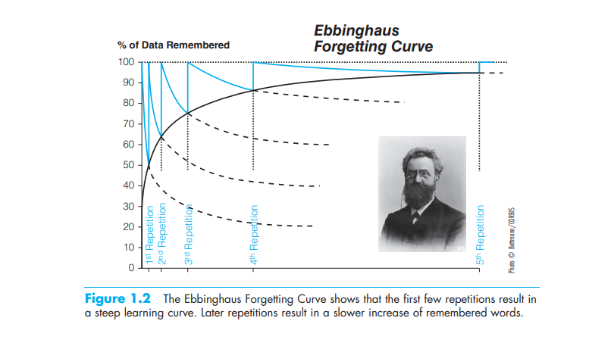
It’s Only What You Can See That Counts: From Associationism to Behaviorism Other researchers who were contemporaries of Thorndike used animal experiments to probe stimulus–response relationships in ways that differed from those of Thorndike and his fellow associationists. These researchers straddled the line between associationism and the emerging field of behaviorism. Behaviorism focuses only on the relation between observable behavior and environmental events or stimuli. The idea was to make physical whatever others might have called “mental” (Lycan, 2003). Some of these researchers, like Thorndike and other associationists, studied responses that were voluntary (although perhaps lacking any conscious thought, as in Thorndike’s work). Other researchers studied responses that were involuntarily triggered in response to what appear to be unrelated external events.
In Russia, Nobel Prize–winning physiologist Ivan Pavlov (1849–1936) studied involuntary learning behavior of this sort. He began with the observation that dogs salivated in response to the sight of the lab technician who fed them. This response occurred before the dogs even saw whether the technician had food. To Pavlov, this response indicated a form of learning (classically conditioned learning), over which the dogs had no conscious control. In the dogs’ minds, some type of involuntary learning linked the technician to the food (Pavlov, 1955). Pavlov’s landmark work paved the way for the development of behaviorism. His ideas were made known in the United States especially through the work of John B. Watson (see next section). Classical conditioning involves more than just an association based on temporal contiguity (e.g., the food and the conditioned stimulus occurring at about the same time; Ginns, 2006; Rescorla, 1967). Effective conditioning requires contingency (e.g., the presentation of food being contingent on the presentation of the conditioned stimulus; Rescorla & Wagner, 1972; Wagner & Rescorla, 1972). Contingencies in the form of reward and punishment are still used today, for example, in the treatment of substance abuse (Cameron & Ritter, 2007). Behaviorism may be considered an extreme version of associationism. It focuses entirely on the association between the environment and an observable behavior. According to strict, extreme (“radical”) behaviorists, any hypotheses about internal thoughts and ways of thinking are nothing more than speculation
Proponents of Behaviorism The “father” of radical behaviorism is John Watson (1878–1958). Watson had no use for internal mental contents or mechanisms. He believed that psychologists should concentrate only on the study of observable behavior (Doyle, 2000). He dismissed thinking as nothing more than subvocalized speech. Behaviorism also differed from previous movements in psychology by shifting the emphasis of experimental research from human to animal participants. Historically, much behaviorist work has been conducted (and still is) with laboratory animals, such as rats or pigeons, because these animals allow for much greater behavioral control of relationships between the environment and the behavior emitted in reaction to it (although behaviorists also have conducted experiments with humans). One problem with using nonhuman animals, however, is determining whether the research can be generalized to humans (i.e., applied more generally to humans instead of just to the kinds of nonhuman animals that were studied). B. F. Skinner (1904–1990), a radical behaviorist, believed that virtually all forms of human behavior, not just learning, could be explained by behavior emitted in reaction to the environment. Skinner conducted research primarily with nonhuman animals. He rejected mental mechanisms. He believed instead that operant conditioning—involving the strengthening or weakening of behavior, contingent on the presence or absence of reinforcement (rewards) or punishments—could explain all forms of human behavior. Skinner applied his experimental analysis of behavior to many psychological phenomena, such as learning, language acquisition, and problem solving. Largely because of Skinner’s towering presence, behaviorism dominated the discipline of psychology for several decades. Criticisms of Behaviorism Behaviorism was challenged on many fronts like language acquisition, production, and comprehension. First, although it seemed to work well to account for certain kinds of learning, behaviorism did not account as well for complex mental activities such as language learning and problem solving. Second, more than understanding people’s behavior, some psychologists wanted to know what went on inside the head. Third, it often proved easier to use the techniques of behaviorism in studying nonhuman animals than in studying human ones. Nonetheless, behaviorism continues as a school of psychology, although not one that is particularly sympathetic to the cognitive approach, which involves metaphorically and sometimes literally peering inside people’s heads to understand how they learn, remember, think, and reason. Other criticisms emerged as well, as discussed in the next section. Behaviorists Daring to Peek into the Black Box Some psychologists rejected radical behaviorism. They were curious about the contents of the mysterious black box. Behaviorists regarded the mind as a black box that is best understood in terms of its input and output, but whose internal processes cannot be accurately described because they are not observable.
Emergence of Cognitive Psychology In the early 1950s, a movement called the “cognitive revolution” took place in response to behaviorism. Cognitivism is the belief that much of human behavior can be understood in terms of how people think. It rejects the notion that psychologists should avoid studying mental processes because they are unobservable. Cognitivism is, in part, a synthesis of earlier forms of analysis, such as behaviorism and Gestaltism. Like behaviorism, it adopts precise quantitative analysis to study how people learn and think; like Gestaltism, it emphasizes internal mental processes.

Approach | Key Idea | Main Contributors | Criticisms | Relevance to Cognitive Psychology
Nativism | Certain knowledge/structures are innate; the mind is not a blank slate. | Plato (early ideas), René Descartes (mind–body distinction), later Noam Chomsky (language innateness). | Can downplay the role of learning and environment. | Supported the idea that the mind has inborn mechanisms (e.g., perception, language acquisition), influencing modern cognitive science.
Empiricism | Knowledge arises from experience and observation; mind as a “blank slate.” | John Locke, David Hume, John Stuart Mill; later empiricist traditions in behaviorism. | Ignores possible innate cognitive structures; may oversimplify learning. | Provided the basis for behaviorism and experimental methods focusing on measurable experiences.
Structuralism | Break down the mind into elementary components (sensation, memory, attention). | Wilhelm Wundt (founder), Edward Titchener (U.S.). | Introspection was unreliable, subjective, and altered mental processes. | Introduced systematic study of consciousness; precursor to experimental psychology.
Functionalism | Focus on processes: what the mind does and why (adaptation, purpose). | William James (Principles of Psychology), John Dewey. | Lacked a clear method; sometimes too broad and pragmatic. | Shifted focus toward applications (learning, memory, education); influenced applied cognitive psychology.
Associationism | Mental processes operate through associations: contiguity, similarity, contrast. | Hermann Ebbinghaus (memory, forgetting curve), Edward Thorndike (Law of Effect). | Overly simple explanations; neglected higher-order cognition. | Laid the groundwork for learning theories, memory research, and later behaviorism.
Dualism | Mind and body are separate entities interacting with each other. | René Descartes (mind–body interaction). | Raises the “mind–body problem”; difficult to test scientifically. | Framed early debates: should psychology study mental contents (structuralists) or only observable behavior (behaviorists)? Cognitive psychology reintroduced the study of mental processes.

